Français 1 222222


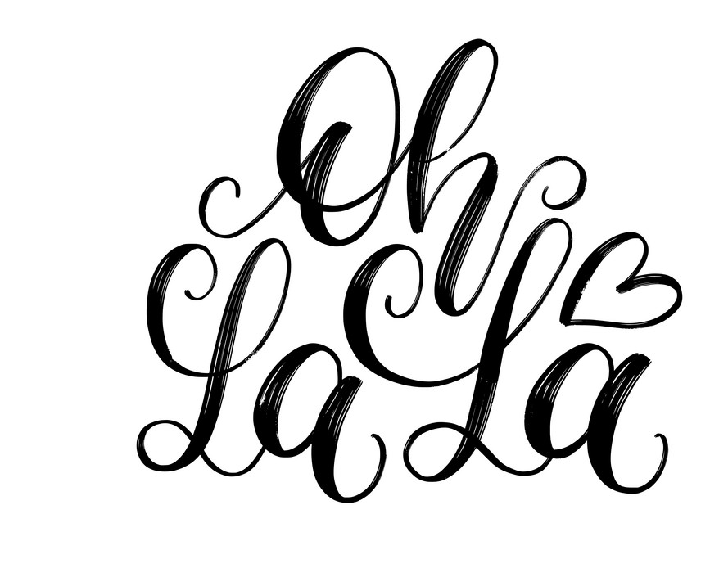

Español 2

Bienvenune!

Mme. Manderson
E-mail: manderson.melissa@lee.k12.al.us
Planning: Quarta

The French 1 course is designed to introduce students to the language and culture of France and of other countries where French is spoken. Instruction will lead to an awareness of the importance of the French language and culture in today’s world. Emphasis is placed upon basic communication skills (reading, writing, listening, speaking) using acquired knowledge of fundamental forms of grammar and pronunciation.

Online Text: T’es Branché? 1



Water only is allowed
in a bottle that has a
tight top.

Supplies:

- 1 ½“ binder and paper OR
- Notebook
- headphones/earbuds
- colored pencils
- pencil
- pen black/blue
Wish list:
- 1 ream copy paper
- 1 container Clorox or Lysol wipes
- Paper towels

Grades:
Major grades: 60%

Minor grades 40%

*When it comes to exemptions, please refer to your Panther Pride handbook.

S’il vous plait, non:
If you break any classroom rule, the consequences are:

- Verbal Warning
- Email Parent/Guardian
- Call Parent/Guardian
- Office referral

*Any severe disruptions will result in an immediate office referral.

- Come to class prepared each day.
- Be in your assigned seat and ready to begin when the bell rings.
- Respect others and their property.
- Keep the room clean.
- Speak at appropriate times using appropriate voice and language.
- Remain seated unless you have permission to move around the room.
- Only work on French work during French class.



ABSENT?
EXCUSED:
YOU are responsible for all notes, assignments, quizzes, or tests.
Any work missed is written as a 0 in Powerschool for an excused absence until the work is completed.
Students have 3 days to complete work for EXCUSED absences.

UNEXCUSED:
Any work missed is a O in Power School for and unexcused absence until such time as it is excused.

Bell Work:
Each week you will be given a sheet for bell work. Keep this in your binder. Start bell work each day upon entering class. Bell work will be graded every two weeks.

Continued from page 1

Puis-je aller aux toillettes?:
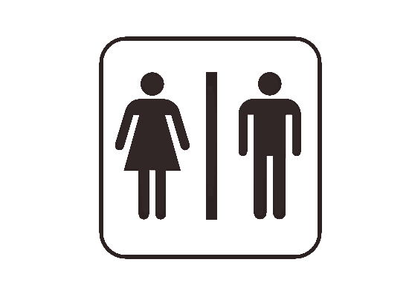
You should go to the restroom between classes. In the case of emergency, you must fill out the E-Hall pass and I will verify it.
Special pass required:
Nurse? Only in an emergency
Media Center? Not during class

Electronic Devices

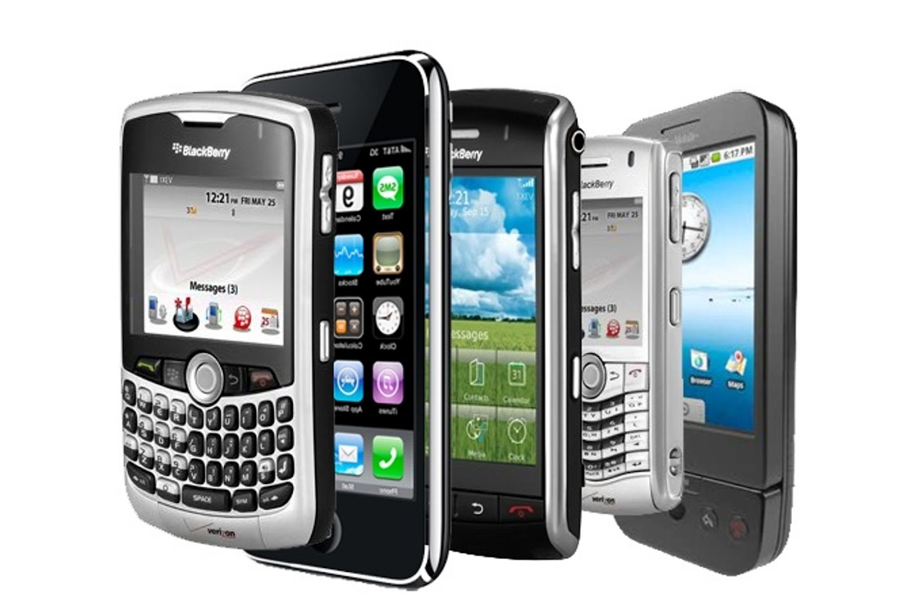
Phones are not allowed out in the classroom. All work is to be done on the student’s Chromebook. Phones should be put away in a backpack or similar bag. All bags are to be left at the back of the room so they do not interfere with computer cords underneath tables.

Dress Code
Dress code will be strictly enforced. You will be given one warning and a chance to correct your infraction. Any infractions after that will result in a referral.


Madame Manderson dismisses class NOT the bell.

“Je ne sais pas.” Is never the answer. I only ask that you try!

